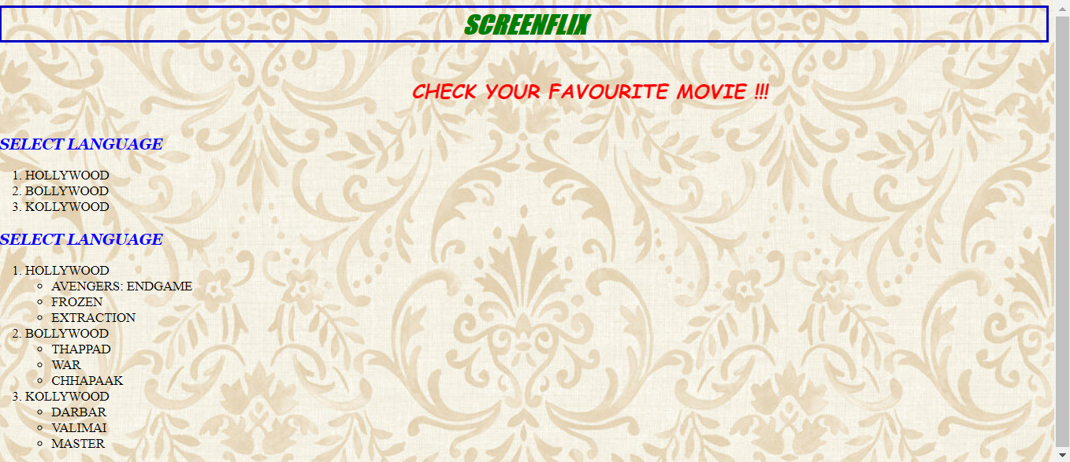

CSS FONT STYLES AND ATTRIBUTES

SCREENFLIX – H1 TAG WITH BOLD TAG IS USED WITH BORDER STYLE IS GROOVE AND BORDER COOR IS GREEN

🡪use font attributes

CHECK YOUR FAV MOVIE – MARQUEE AND H2 TAG WITH CLASS ATTRIBUTE IS USED FOR CSS COLOR

🡪use font attributes

SELECT LANGUAGE – H3 TAG WITH CLASS ATTRIBUTE IS USED FOR CSS COLOR

🡪use font attributes

HOVERING ON THE LIST ITEM USED WITH CSS COLORS